Parking Directions:
Canterbury Consulting
610 Newport Center Drive Suite 500
Newport Beach, CA 92660

Depending on how you enter the area where our building is located there are two directions, so I’ll include both. This is what it would look like if they come from the direction of Center Drive You can turn off San Juaquin onto Center Drive and the photo on the left is what they will see. As you can go straight, you will see the view on the right directing you to the 600/610 parking structure and you will see the courtyard on your right.
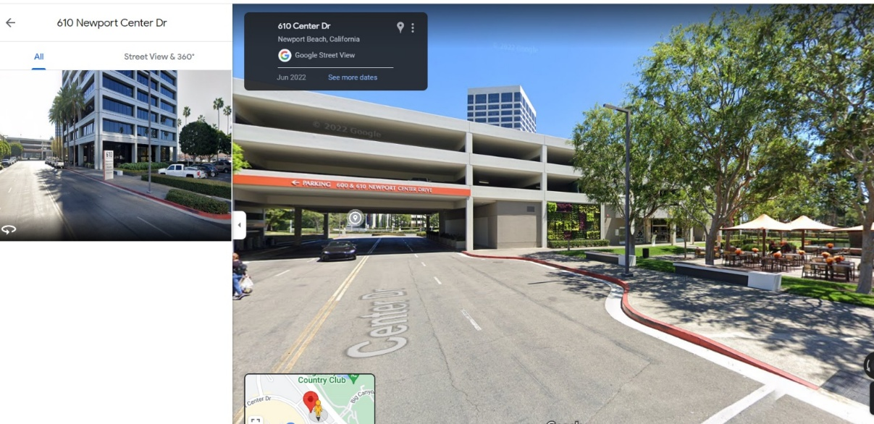

If you come from Santa Rosa Drive, you should turn into first parking structure you see and then walk through the courtyard to enter the 610 building.
This is what the view looks like when you enter from Santa Rosa Drive. The entrance is immediately on your right as you enter the parking structure.
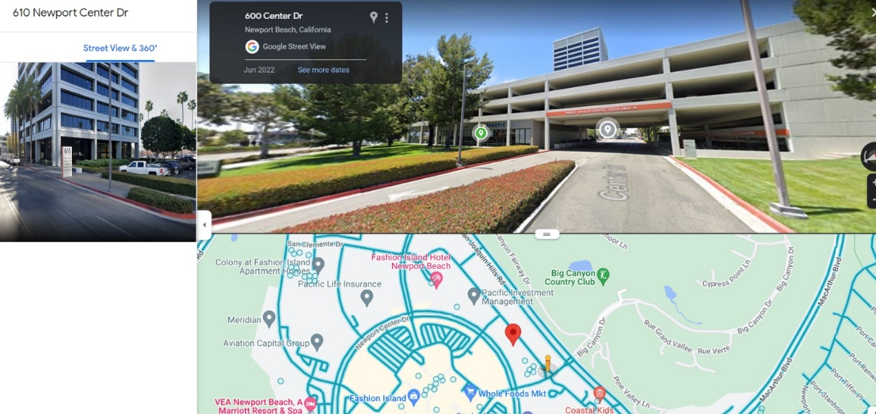
When you enter the 610 building structure, our fifth floor requires a key to access. Our receptionist, Lisa Phillips, will be there to escort you to our floor 15 minutes before the luncheon begins.

If you arrive earlier or after, please call 949-721-9580. Let them know that you are here for the Southern California Compliance Group Meeting and someone will escort you up.

